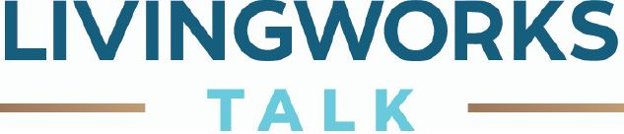
FOR MORE INFORMATION: https://www.livingworks.net/
http://www.livingworks.com.au/
About LivingWorks TALK
LIVINGWORKS TALK is a half-day suicide alertness workshop that prepares you to become a suicide-alert helper. Most people with thoughts of suicide don’t truly want to die, but are struggling with difficulties in their lives. Through their words and actions, they invite help to stay alive. LIVINGWORKS trained helpers can recognize these invitations and take action by connecting them with life-saving resources. The program is used in over 20 countries around the world, and LIVINGWORKS trained helpers are an important part of suicide-safer communities, working alongside other people and services to identify and avert suicide risks.

Who should attend LivingWorks TALK?
LIVINGWORKS TALK offers valuable skills to anyone 15 years and older and requires no formal training or prior experience in suicide prevention. Because it only takes half a day to learn, LIVINGWORKS TALK is an excellent tool for people who want to become alert to the dangers of suicide in a convenient timeframe. Although formal caregivers such as social workers and counsellors employ LIVINGWORKS TALK skills, the program is also used by students, teachers, community volunteers, first responders, military personnel, police, public and private employees, and professional athletes—among many others.

Who provides LivingWorks TALK workshops?
LIVINGWORKS TALK workshops are provided by registered LIVINGWORKS trainers. In addition to the trainer, each LIVINGWORKS TALK workshop includes a community resource person who is on hand to recommend services and programs that can assist someone at risk. Referring someone to these connections is an important part of the LIVINGWORKS TALK model. The community resource person can also provide assistance and support if any participants are struggling with the subject of suicide in the workshop. For the RHealth

What can I expect at a LivingWorks TALK workshop?
You can expect to feel challenged, empowered, and hopeful. Your LIVINGWORKS trainer will demonstrate the importance of suicide alertness and help you identify ways people invite help when they’re at risk. LIVINGWORKS TALK’s steps provide a simple yet effective method to engage with people at risk and connect them with service providers who can carry out a full-scale intervention. You can expect to leave LIVINGWORKS TALK with practical knowledge of how to identify someone at risk and link them to life-saving services and resources.

Workshop features:
- Presentations and training from a registered trainer provided by Lifeline DDSWQ
- Support from a local community resource person – RHealth’s Mental Health Navigators
- Powerful audio-visual learning aids
- The simple yet effective TALK steps: Tell, Ask, Listen, and KeepSafe
- Skills practice and development of the TALK steps

